Cell Structures and Functions Project

Assigned: November 13th, 2013
Due Date: November 22th, 2013

Learning Target: LS1-2. Develop and use a model to describe the function of a cell as a whole and ways parts of cells contribute to the function

For this project you will share your knowledge about plant and animal cells, the important structures inside a cell that serve in assuring the cell’s survival. You will choose ONE type of cell to build:
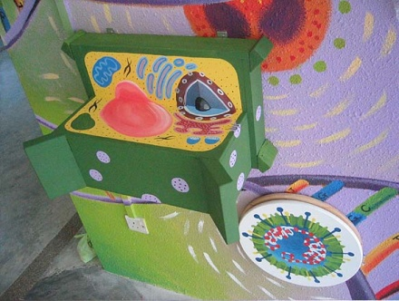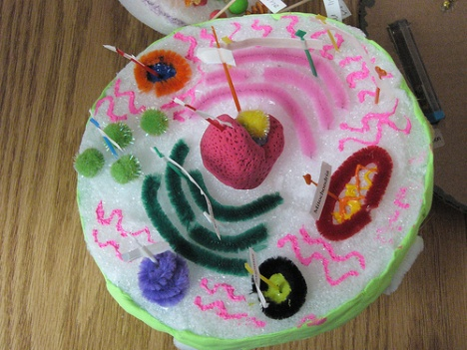

You can create a PLANT cell OR You can create an animal cell

Your model needs to meet the following criteria:
- It must have all the following parts:
Plant cell: Cell wall, cell membrane, nucleus with nucleolus and chromosomes, nuclear membrane, cytoplasm, mitochonria, vacuole, chloroplasts, endoplasmic reticulum, ribosomes, golgi bodies
Animal cell: Cell membrane, nucleus with nucleolus and chromosomes, nuclear membrane, cytoplasm, mitochonria, vacuoles, lysosomes, endoplasmic reticulum, ribosomes, golgi bodies
- All parts must be labeled. Labels need to be typed or written very neatly with colored markers
- Function of each part needs to be included in some way
- All text to explain the functions of the structures needs to be TYPED
- Model development will be assessed using the Development and Use of Models rubric on the back of this page.
- Model must be 3-Dimensional and needs to be able to stand alone or hang from the ceiling

